**Fluke Tech Support GPT – Technical Document**

Fluke Tech Support GPT is for internal Fluke techies, it is intended to get the answers for the questions that the technical team having. The bot provides the answer by scanning the Knowledge base, web site data, SharePoint locations.

**Flow Diagram**

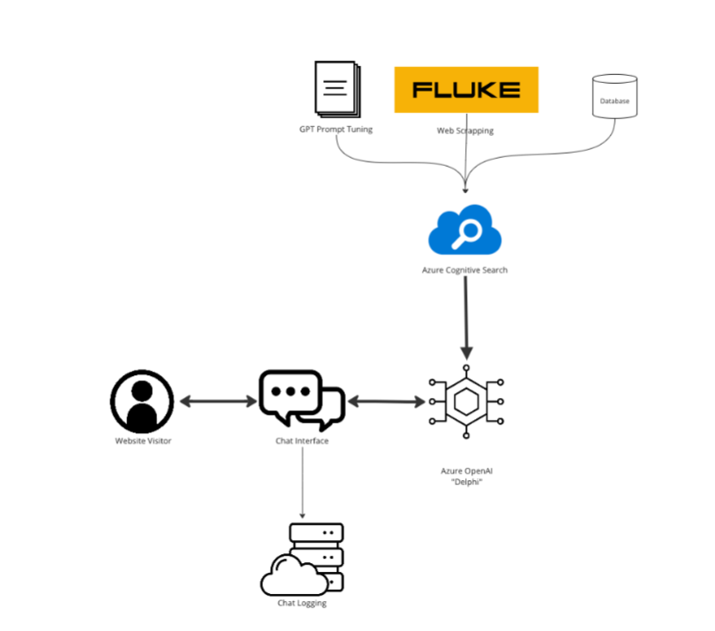

Fluke Tech Support uses a chatbot or a conversational agent based on a GPT (Generative Pre-trained Transformer) model to capture sessions created by users. The details of these sessions are then stored in an Azure MySQL database.

**Conversational Agent (GPT):**

The GPT model, possibly a variant like GPT-3.5 Turbo 16K, is utilized as a chatbot or conversational agent. It understands and generates human-like responses based on the input it receives from users during support sessions.

**Session Management:**

The system should manage user sessions, keeping track of interactions and maintaining context during the conversation. This involves capturing user inputs, processing them using the GPT model, and managing the flow of the conversation.

**Data Capture:**

Relevant information from each user session, such as user queries, responses generated by the GPT model, timestamps, and any other pertinent details, is captured and prepared for storage.

**Azure MySQL Database:**

An Azure MySQL database is used to store the captured session details. The database schema includes tables to store information like user IDs, timestamps, session content, and other necessary metadata.

**Data Storage and Retrieval:**

Sessions' details are inserted into the MySQL database for persistent storage. Additionally, the system might include mechanisms to retrieve historical session data for analysis or reference.

**Features:**

1. Answers the complex technical queries from Fluke Knowledgebase.

2. GPT Bot is indexed with additional share point data & web data.

3. Provides share point URL for the documents in addition to web links

4. Provides folder path additionally apart from the document URL

5. Answers the questions related to Fluke product features and fixing Procedures

6. Addresses questions related to Product repair, service, spare parts & warranty

7. When answer is not found, bot suggests the most relevant document folder from share point.

8. Facility to like/dislike for the bot answer.

**Architecture Diagram:**

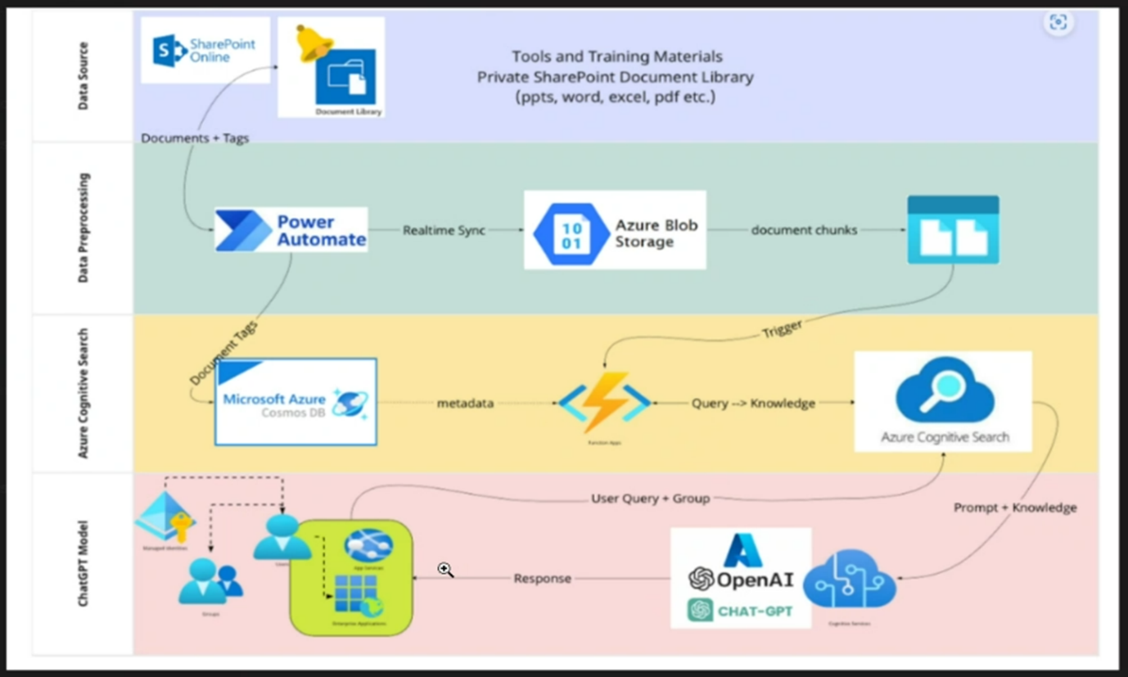

**Prod service name details:**

|  |  |
| --- | --- |
| Resource Group Name | flk-techsupport-gpt-prd |
| Database Name | db-flktsgpt-prd-001.database.windows.net |
| Database Table name | Tblbotchat,Chathistory |
| Cosmos DB service name | cosmos-flktsgpt-prd-eastus-001 |
| Cosmos DB container name | flktscontainer |
| Function App service name | func-flktsgpt-prd-eastus-001 |
| Open AI service name | flk-techsupport-gpt-prod-openai |
| Storage Account name | stflktsgptprdeastus001 |
| Container registry name | registryflktsprd001 |
| Form Recognizer name | form-flktsgpt-prd-eastus-001 |
| Cognitive search name | cog-flktsgpt-prd-eastus-001 |
| Event grid (Trigger) | eg-flktsgpt-prd-eastus-001 |

**stflktsgptprdeastus001:** All the Fluke data are stored in the Blob container **flktsgpt-source-container**.

**func-flktsgpt-prd-eastus-001**: Document chunking logic and indexing logic are handled in this function app service.

**cosmos-flktsgpt-prd-eastus-001**: Stores the chunking meta data i.e. File name, SharePoint URL …etc

**eg-flktsgpt-prd-eastus-001:** This will trigger the function app (**func-flktsgpt-prd-eastus-001**) when there is a change in the Azure blob container (**flktsgpt-source-container**).

**form-flktsgpt-prd-eastus-001:** This service is used for extracting data from .pdf, .docx, .csv file.

**registryflktsprd001:** This service is used for storing the docker images for deploying front/back end.

**Dev link details:**

|  |  |
| --- | --- |
| Application URL | <https://delphiapi-flkts-frntend-ui-dev-eastus-003.azurewebsites.net/> |
| Resource Group | <https://portal.azure.com/#@fortive.onmicrosoft.com/resource/subscriptions/52a1d076-bbbf-422a-9bf7-95d61247be4b/resourceGroups/flk-techsupport-gpt-dev/overview> |
| Front end Git URL | https://gitlab.com/fortive/fluke/fluke-techsupport-gpt-kataui.git |
| Back end Git URL | <https://portal.azure.com/#@fortive.onmicrosoft.com/resource/subscriptions/52a1d076-bbbf-422a-9bf7-95d61247be4b/resourceGroups/flk-techsupport-gpt-dev/providers/Microsoft.Search/searchServices/cog-flktsgpt-dev-eastus-001/overview> |

**Production link details:**

|  |  |
| --- | --- |
| Front end URL | https://delphiapi-flkts-frntend-ui-prod-eastus-002.azurewebsites.net/ |
| Resource Group | <https://portal.azure.com/#@fortive.onmicrosoft.com/resource/subscriptions/52a1d076-bbbf-422a-9bf7-95d61247be4b/resourceGroups/flk-techsupport-gpt-prd/overview> |

**Pipeline for updating data sources:**

Below pipelines will be triggered when there is change in the data source

|  |
| --- |
| Data source:  <https://fortive.sharepoint.com/sites/FTV-FTV-OpenAI-Readers/Shared%20Documents/Forms/AllItems.aspx?fromShare=true&ga=1&id=%2Fsites%2FFTV%2DFTV%2DOpenAI%2DReaders%2FShared%20Documents%2Ffluketsgpt&viewid=8a7e4fa6%2D859e%2D4c62%2Dba09%2Dc00b3982d35c> |
| New document ingestion:  https://portal.azure.com/#@fortive.onmicrosoft.com/resource/subscriptions/52a1d076-bbbf-422a-9bf7-95d61247be4b/resourceGroups/flk-techsupport-gpt-prd/providers/Microsoft.Logic/workflows/logic-get-updated-file-flktsgpt-prod/logicApp |
| Old document removal:  <https://portal.azure.com/#@fortive.onmicrosoft.com/resource/subscriptions/52a1d076-bbbf-422a-9bf7-95d61247be4b/resourceGroups/flk-techsupport-gpt-prd/providers/Microsoft.Logic/workflows/logic-delete-file-techsupport-prd/logicApp> |

Fluke Tech Support GPT stores the Chat details i.e Chactid, Chat history, time of the chat conversation

in the Azure SQL Database.

**PowerBI report:** [FlukeTechSupportGPT - Power BI](https://app.powerbi.com/groups/me/reports/d1a5fe57-a77c-4c04-b32f-1bb6751ed364/ReportSection30575c8415d74a191c81?experience=power-bi)

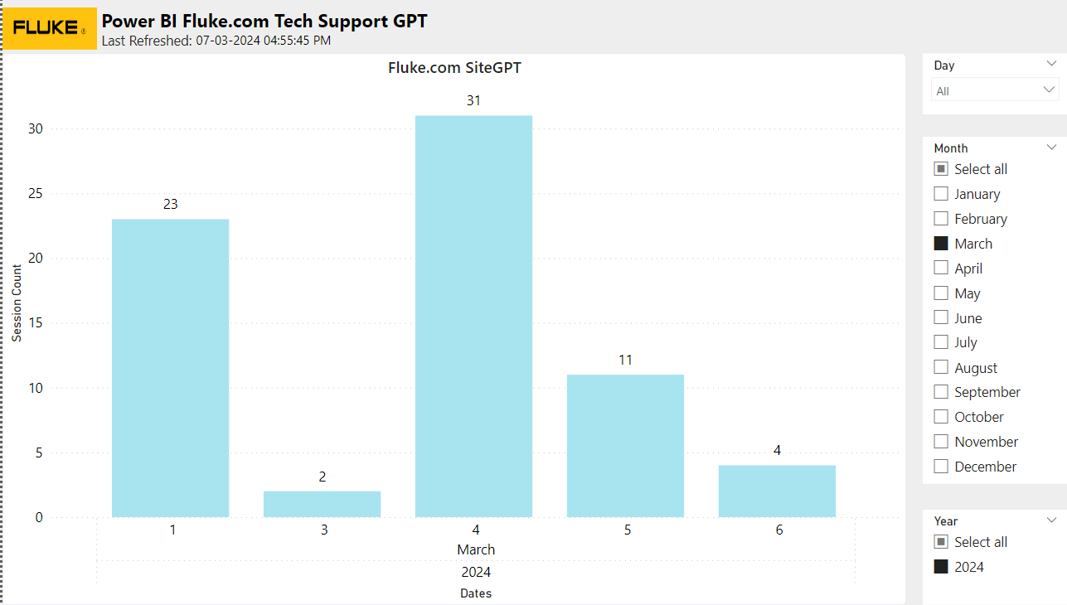s